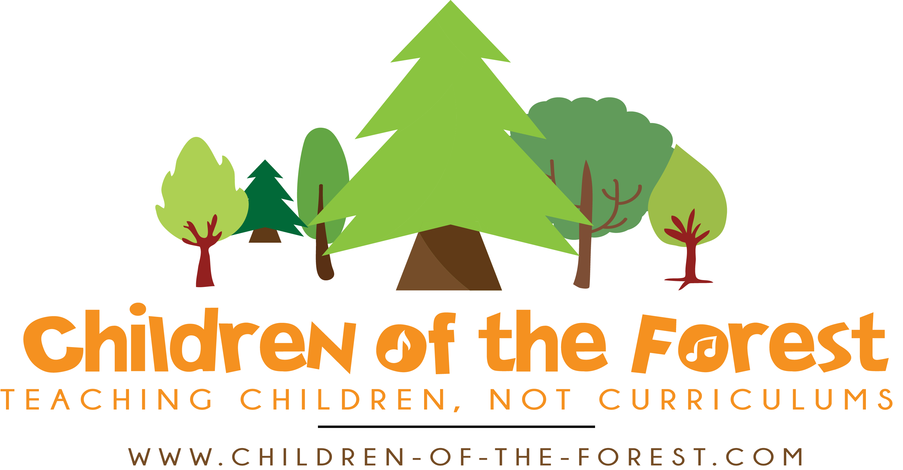
Work Experience at Children of the Forest
Information and Person Specification

Thank you for your interest in a work experience placement at Children of the Forest. Please find below some information about what the job entails, to help you to decide if you’d like to spend your work experience with us.

What is Forest School?

Forest School is a unique approach to learning, based outdoors in a natural setting. Groups are regular and long term. Learners are offered opportunities to learn about the natural world, to move their bodies and explore, to be creative, to built a sense of community and, importantly, to play and make their own choices.

Activities on offer can include physical games, den building, tree climbing, bug hunting, arts and crafts, campfire cooking, bushcraft such as firelighting and whittling, woodland management, music and drama. However, none of our activities are forced and children are free to choose how to spend their time. We Look After Ourselves, Look After Each Other, and Look After the Forest.

For more information see our website www.children-of-the-forest.com and the Forest School Association https://forestschoolassociation.org/full-principles-and-criteria-for-good-practice/

About Children of the Forest
Lewis and Gemma are both former school teachers turned forest school leaders who have created Children of the Forest Children of the Forest has served children, families and schools in the local community since 2017. We also train adults in forest school practice and create The Forest School Podcast. We are Forest School Association Accredited providers, which means we offer forest school of a high standard closely following the FSA’s principles. We have experience of running all kinds of forest school programmes, from pop-up sessions on school fields, to festivals, to our own Forest Kindergarten. You can find out more info at our website https://children-of-the-forest.com/

What is the time commitment involved?
We are open at the following times. Please note, this may mean that you will need to find an alternative placement or activity for the other days of your work experience.

- Wednesdays 9.00-3.30: Free to Learn Home Ed Group, ages 5-12
- Thursdays 9.00-3.30: Free to Learn Home Ed Group, ages 5-12
- Fridays 9.00-12 and 12pm-3pm Little Acorns Toddler & Carer Group, ages 0-5

What does the work experience include?
Students on work experience are there as an extra pair of hands before, during and after a forest school session.

This could include:
- playing games with the learners, when invited
- joining in with group circle time and group activities
- supporting children, including those with additional needs
- helping with giving out / packing away resources
- helping to set up activities and tidying up
- helping with bushcraft or woodland management
- being a friendly face for learners to talk to
- sharing their own interests and skills with the group, if they would like to
- learning new skills alongside the group, such as nature identification, bushcraft skills, tool use, crafts, songs and campfire cooking
- reflecting after a session with Wem & Lewis, sharing observations and thoughts

Work experience students will be asked to:

- Follow Children of the Forest’s approach concerning play, risk and behaviour support
- Follow policies regarding safeguarding of children and safety
- Behave in a way that is appropriate to working with children and in the Forest School ethos
- Observe confidentiality at all times

Work experience students will not:
- Be asked to administer First Aid if they are not qualified
- Be asked to use tools or work with fire, or supervise learners doing so, unless they are confident and fully briefed / trained
- Be asked to plan any parts of a session, unless they would like to

Other practical information:
- Sessions happen in all weathers except dangerously high winds - we have shelters for rain, but our site is entirely outdoors. Part of our site is on a slope, it can be muddy. Volunteers will need appropriate outdoor warm clothing and waterproofs and sturdy footwear. Volunteers will need to bring their own lunch and drinks.
- Our site is 3 acres of private woodland, located at EX15 3FJ. Unfortunately there is currently no public transport.

This work experience placement would suit someone who:

- Is enthusiastic about working with children, including those with additional needs
- Enjoys being outdoors in all weathers
- Is interested in forest school or learning about it
- A positive attitude and the confidence to ‘have a go’

How do I apply or find out more?

If you are interested in applying to do your work experience with us, please fill out the application form found at https://children-of-the-forest.com/vacancies and email it to us at childrenoftheforest@outlook.com.

