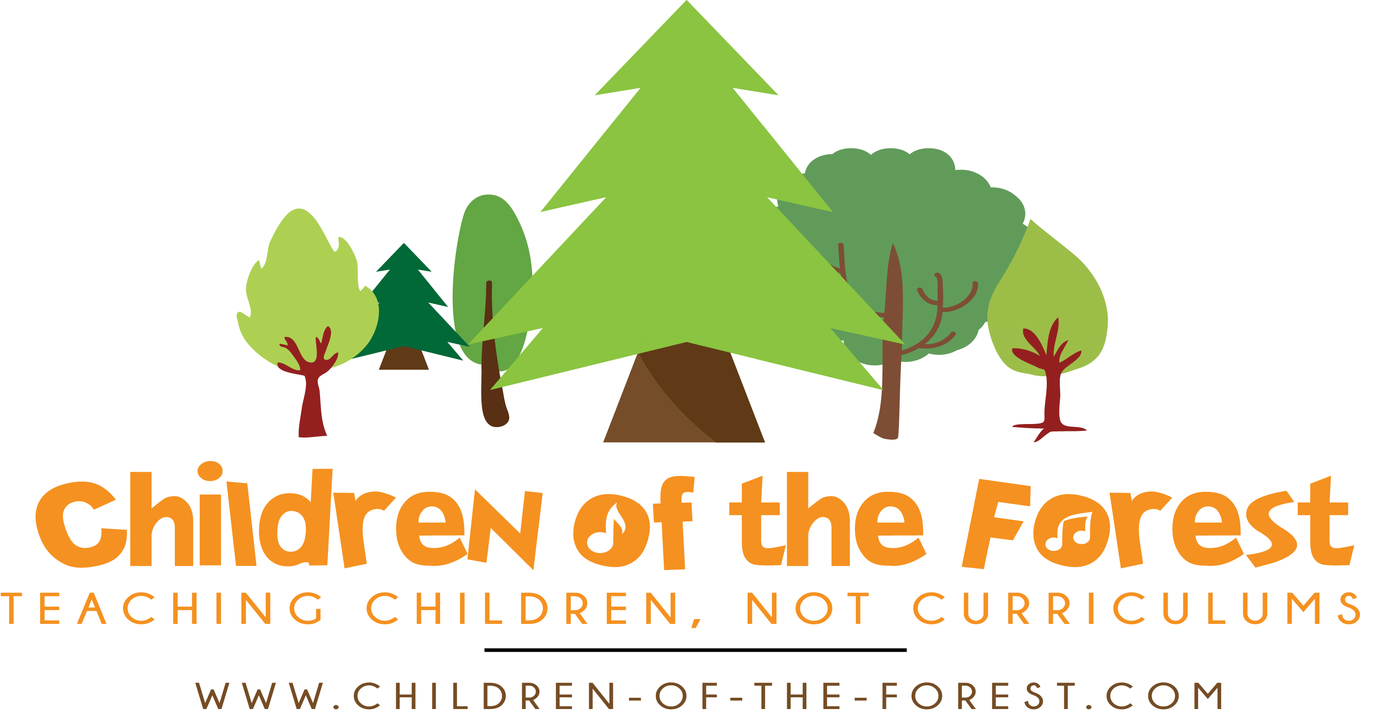

Volunteer Application Form

Please complete this form in type or black ink and email to childrenoftheforest@outlook.com

Which volunteering post are you applying for? You may select as many as you like | Weds group ages 5-12, 9.30am-2.45pm |  | Thurs group ages 5-12, 9.30am-2.45pm |  | Fri adult & toddler group 9.30-11.30 |  | Occasional school holiday clubs age 5-12, 9am-3pm

Are you able to commit to volunteering for at least a school term (13 weeks)? Yes / No

First name(s): |  |  |  |  | Surname:
Address:
 |  |  |  |  |  |  | Post Code:
Home Telephone Number: |  |  |  |  |  |  |  | Mobile:
 |  |  |  | E-mail Address:

Personal statement

Having read the volunteering description and person specification, please state why you are interested in volunteering and how your experience and achievements to date would make you a suitable volunteer with Children of the Forest.

Please give the names and full addresses of two people who we can contact as references. Both should be people who know you in a professional capacity and can vouch for your relevant experience and character. Please do not use relatives, partners or friends as referees.
Name: |  |  |  | Name:
Position: |  |  |  | Position:
Relationship: |  |  |  | Relationship:
Address: |  |  |  | Address:
Tel: |  |  |  | Tel:

YES/NO
Please indicate whether your referees can be approached now. .

Do you currently hold a DBS Certificate?: YES / NO

If yes, certificate number:_____________________________

Are you subscribed to the DBS update service? YES / NO

Have you ever been convicted, cautioned or reprimanded for a criminal offence? YES/NO

If YES, please give details and date(s) in the space provided below:

Are you or anyone else who lives in your household disqualified from working with children or vulnerable adults? YES / NO

If YES, please give details below:

Do you regularly take any medication which may affect your ability to work with children? YES / NO
If YES please give information below:

Qualifications Achieved (start with most recent):
Secondary Schools,  Colleges, Universities | From: | To: | Brief Details of Courses/qualifications undertaken: | Grade:

Study currently being undertaken:
Secondary Schools  Colleges, Universities | From: | To: | Brief Details of Courses: | Grade:

Professional or other qualifications, apprenticeships, memberships of professional organisations:

Other training you have received which you consider relevant:

Do you have a driving licence? YES/NO Do you have reasonable access to public transport? YES/NO

Do you have access to a vehicle? YES/NO

Do you hold a current Paediatric First Aid certificate? YES / NO
If Yes, please give expiry date:

Employment:
Current/most recent employer:
Address:
 |  |  |  |  |  |  |  |  | Post Code:
Date Started: |  |  |  |  |  | Until:
Job Title:
Brief Description of Duties:
Reason for leaving if applicable:

Other employment/career history starting with most recent:
For posts which involve working with children, please give full employment history, accounting for any gaps (please continue on a separate sheet of paper if necessary).

From: | To: | Employer:  Name and Address: | Post: | Reason for Leaving:

Please give details of other interests, including involvement in voluntary organisations which you consider relevant:

Do you have any relationship (i.e. family, friends) with anyone currently working for Children of the Forest? Yes / No
If yes, please provide details below:

Recruitment Monitoring Form – confidential

Equality and Diversity

We are committed to Equality and Diversity in Employment. As part of this policy, all applicants for employment are requested to complete this section for the purposes of monitoring the policy and it will be separated from your application. The information it contains will not be used in deciding whether or not to invite you to interview or offer you a volunteering position. As an Equal Opportunities Employer, we aim to ensure that no job applicant or employee receives less favourable treatment on the grounds of age, sex, race, colour, marital status, religion, ethnic origin, disability, nationality or sexual orientation. Please help us to achieve our main aim by completing the following questions:

Position applied for: Volunteer

Name: surname and forename(s) in full:
Date of Birth: |  |  | Age:

Gender:

Male |  | Female: |  | Non-binary

Disability:

Do you consider yourself to have a disability? Yes  If YES and you would like to tell us more, for instance if  you are invited to attend for interview or to take up volunteering and require special arrangements, please give details below: |  | No

I would describe my race or ethnic origin as (please tick appropriate box):

White |  |  | Black |  |  | Asian
White British |  |  | Black British |  |  | Bangladeshi
White Irish |  |  | Black African |  |  | Pakistani
White Other |  |  | Black Caribbean |  |  | Indian
 |  |  | Black Other |  |  | Asian Other
Chinese |  |  | Mixed |  |  | Other please state:
Chinese |  |  | White & Black Caribbean
Chinese Other |  |  | White & Black African
 |  |  | White & Black Asian
How did you find out about this volunteering opportunity?
(please give the name of the newspaper/journal/website)
I consent to Children of the Forest holding the data in the recruitment monitoring section of this form.
Signature of applicant: |  |  |  |  |  |  | Date:

Declaration

Any of the above particulars may be subject to check. I understand that any false, inaccurate or incomplete information could result in a withdrawal of any offer of volunteering position.

I declare that the information given on this form is to the best of my knowledge correct and complete and can be treated as part of any subsequent volunteering arrangement.

I understand that Children of the Forest may process, by means of a computer database or otherwise, any information which I provide to it, for the purpose of volunteering with Children of the Forest.

Signature: |  | Date:

