Forest School Leader Level 3 Training
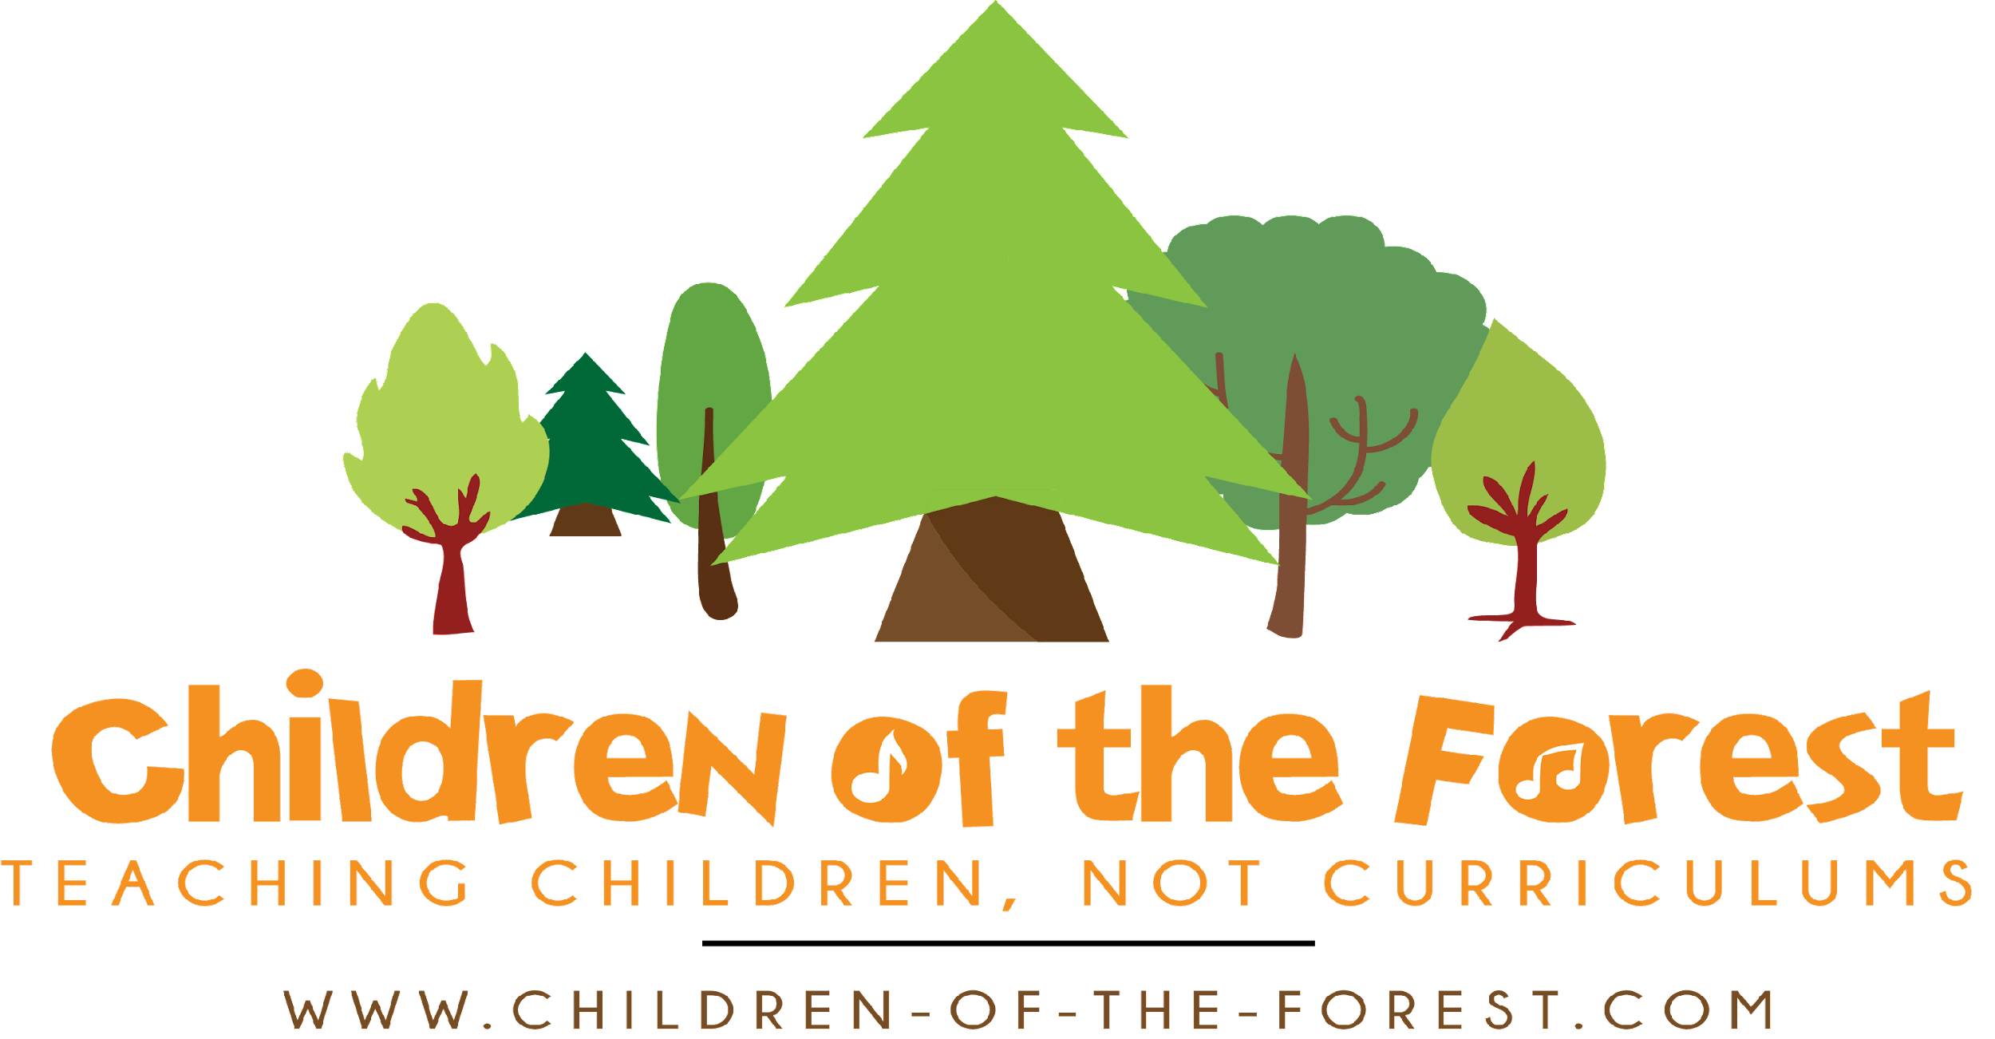
Terms & Conditions

The information below must be read thoroughly and carefully before any booking is made. These terms and conditions are not subject to variation without prior consent in writing from Children of the Forest Ltd. Once a booking has been accepted by written confirmation, or by electronic means including BACS transfer or Go Cardless, the client(s) named on will have entered into a binding contract on the basis of the following Terms and Conditions. If you have any questions, please do not hesitate to contact us. “Children of the Forest” means Children of the Forest, 3 Hartley Drive, 3 Hartley Drive, Hemyock, Cullompton, Devon, England, EX15 3FW (Registered business postal address); The View, Ashill, Cullompton, Devon EX15 3FJ (site address).

1. Agreement
Any agreement based on the outlined terms and conditions arise upon the fulfilment of the following:

a) Receipt and clearance in Children of the Forest’s bank account of full payment or non-refundable deposit as detailed in section 2 below.

b) That the person named on the booking is taken as the client attending the course or by a legally recognised agent of the client for and on their behalf unless otherwise specified.

c) The Agreement is between Children of the Forest and the client(s) booking and is the sole agreement between those parties.

d) Children of the Forest reserves the right to refuse bookings to any party or individual without need to give reasons solely at Children of the Forest’s discretion and we will return any payment accompanying the booking.

2. Payment of Forest School Level 3 courses
All forest school leader training needs to be paid in full before the commencement of the training.

No one will be submitted for certification until full payment has been received. Late payments will be subject to the same terms as laid out above. Applications submitted without payments will not have a guarantee of a place on the training programme.

Course attendees have a set time to complete their coursework. Different modules will have different time requirements and students will be given these date on their face to face training week. If their submissions are past these dates and they still want to complete the course then they will need to contact their tutor to request an extension - see Clause 6 below.

3. Cancellation of course
After paying for the course, your consumer rights allow 14 days in which to change your mind, for a full refund - unless the course has already started during this time. Once the delivery of the course begins, no refunds can be given.
Given the substantial preparation by Children of the Forest prior to any course, the client must be aware of the following conditions and therefore agrees to such. Please let us know as far in advance as possible if you wish to cancel, as your place may be offered to another on the waiting list. If your booking is cancelled for any reason the following charges will be applied:

a) Cancellation 4-8 weeks before course commencement will lead to 50% of the course cost being payable, unless the space can be taken by another client on the waiting list. In this case, the course costs will be fully refunded.

b) Cancellation less than 4 weeks before course commencement 100% of the course fee will be required by Children of the Forest.

4. Variation of the course by Children of the Forest
The Forest School Leaders’ course is held almost entirely outdoors. It is therefore subject to changes brought about by extreme weather conditions, such as high winds. In the event of weather changing the course content or timetable, every effort will be made to find alternative venues or dates for the course. Please note there will usually be one alternative date given, there is no guarantee that different dates can be offered for every student. Where these changes are beyond our control, in such circumstances it is not reasonable for Children of the Forest to be liable for any losses as a result and that our liability is limited accordingly.

5. Non-attendance
In order to pass the course, students must have a 90% attendance rate at our face-to-face days. We very strongly recommend that students prioritise the Forest School Leader training course, as every hour spent on face-to-face training supports not only the guided hours requirements, the ability to complete coursework and practical assessments, and also our own quality standards at Children of the Forest.

As the course is 10 face-to-face days, this means that if more than one day is missed, the pass will not be achievable. Students may be able to join the next cohort of students at Children of the Forest, or in exceptional circumstances tutors may be able to arrange face-to-face additional hours which may incur a cost.
6. Non-submission of coursework & Extensions
You will be given one year to complete the course, which starts on the start date of your practical training sessions. It is a Level 3 qualification and we expect one year to be a reasonable time frame for you to complete your work.

You are required to submit coursework by the deadline given by your tutors. This will be told to you during the Practical Week. You are encouraged to submit coursework early, so that it can be marked by the tutors and feedback given to ensure your success. Tutors are available at all times by email to assist with any coursework-related questions.

If you feel you will not be able to submit your coursework by the deadline, please contact us as soon as possible, and at least five working days before the deadline to either withdraw from the course or request an extension. If you require an extension of more time, we can arrange an extension of an additional year. The charge for this is £120. This fee can be waived in extenuating circumstances; please ensure you contact us in good time to discuss any barriers to your completion of the course.

We are unable to accept any submissions of work more than two years after the course completion date. After this date, retraining must be undertaken in line with AIM policy and guidance.

7. Client conduct
Children of the Forest clients are expected to behave in a reasonable manner at all times and to comply with the reasonable instructions and leadership of Children of the Forest. Children of the Forest reserves the right to remove any client(s) from the course at the instructor/leader’s absolute discretion without recourse to repayment for that course and against the client(s) will if necessary. Circumstances that may warrant exclusion from a course includes (without limitation): intoxication, use of non-prescription drugs, abusive behaviour, inability to meet the rigours of the course from physical or mental reasons, or through lack of appropriate equipment. If you are in any doubt about your ability to meet the rigours of the course, please contact your GP before booking. For removal of any party under such conditions, Children of the Forest will not be liable to any losses as a result and Children of the Forest is also entitled to any reasonable costs arising from removal of said client(s) payable upon demand.

8. Insurance
Children of the Forest is covered by Birnbeck Insurance for Public Liability and is insured as a Forest School Provider. As stated in the Course Booking page, students will need to arrange their own insurance for their six ‘Introduction to Forest School’ sessions.

9. Liability
Children of the Forest courses take place in the outdoors, which by its nature is never completely free from hazard. While all reasonable precautions are taken to minimise the risks the client accepts that accidents including serious injury and death can occur without Children of the Forest being at fault. The client also recognises that Children of the Forest is not responsible for loss or damage to the personal property of the client including vehicles, money, clothing and/or equipment. Woodcraft School also takes no responsibility for any mishap during a course from any instruction or information not given by Children of the Forest appointed instructors or assistants. Children of the Forest also takes no responsibility for any mishaps occurring as a result of the clients failure to follow instruction. Children of the Forest will only accept liability for physical injury to a client that is shown to result from negligence on the part of Children of the Forest.

10. Cancellation by Children of the Forest
In the event that Children of the Forest cancels a course due to reasons within our control, all monies will be refunded in full, or if preferred, transferred as a deposit for another course. Please note that Children of the Forest requires a minimum number of clients to run a course. Children of the Forest reserves the right to cancel all and any bookings without reason or notice. Under these unlikely circumstances Children of the Forest agrees to repay in full all and any deposits or course fees to the client. Please also see Clause 4 above.

11. Complaints
In the unlikely event that a client has cause for complaint about a Children of the Forest course, the complaint should be made to a representative of Children of the Forest during the event in order that corrective action can be taken if necessary. If the complaint is about a member of staff then please contact the office and we shall inform you of the complaints procedures so we can take the necessary action. A complaint must be made immediately. Children of the Forest will not accept a complaint after the end of the course. However, should a problem not be resolved at source, a complaint should be made in writing within 28 days or this complaint will not be upheld.

12. Allergies
If you suffer from severe allergies from substances such as nuts etc, please inform us as soon as possible particularly if you think it will effect your participation in certain elements of your course.

